100th Annual Meeting of the British Association of Dermatologists – Manchester July 7th – 9th 2020
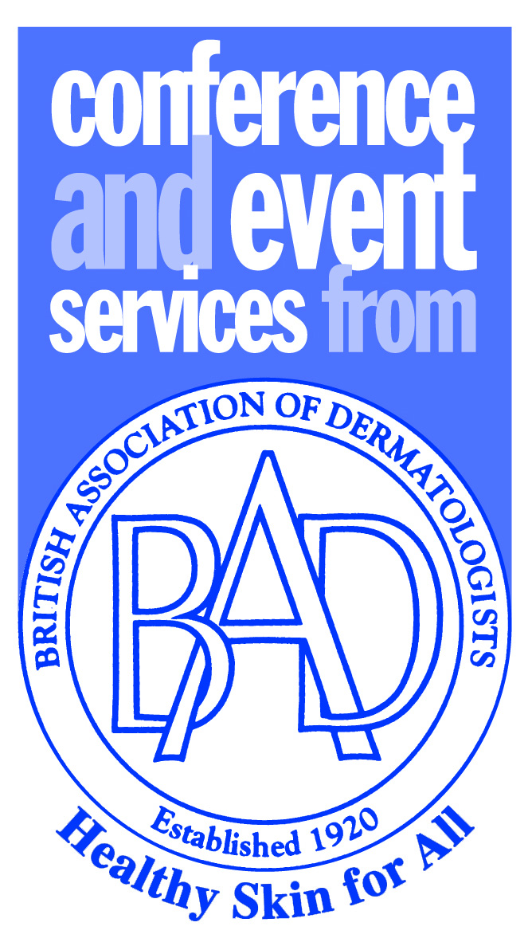

PROPOSAL FORM - ORGANISATION OF SATELLITE SYMPOSIA

Choice of Symposia Slot:

Please indicate 3 choices for your satellite time, marked in order 1st, 2nd & 3rd. We will endeavour to allocate your first choice but this may not always be possible or appropriate:

Slot | Location | Room | Date | Capacity | Price | CHOICE (1st,2nd, 3rd)
1 | Central Foyer | Cobden | Wednesday 8 July, 07:45 – 08:30 | 221 | £4,000 + VAT
2 | Exchange Upper | Exchange 8-10 | Wednesday 8 July, 07:45 – 08:30 | 300 | £4,000 + VAT
3 | Central Foyer | Cobden | Wednesday 8 July, 12:45 – 13:45 | 221 | £17,500 + VAT
4 | Exchange Upper | Exchange Hall | Wednesday 8 July, 12:45 – 13:45 | 300 | £17,500 + VAT
5 | Exchange Upper | Exchange 8-10 | Wednesday 8 July, 12:45 – 13:45 | 300 | £17,500 + VAT
6 | Central Foyer | Cobden | Wednesday 8 July, 18:15 – 19:00 | 221 | £4,000 + VAT
7 | Exchange Upper | Exchange 8-10 | Wednesday 8 July, 18:15 – 19:00 | 300 | £4,000 + VAT
8 | Exchange Upper | Exchange 8-10 | Thursday 9 July, 07:45 – 08:30 | 300 | £4,000 + VAT

Proposal Programme
Please provide as accurate a programme timetable as possible for your Symposia, including both accepted and proposed Chairs and Speakers. This information will be used by the committee to decide if your proposal will enhance the educational benefits of the meeting and should therefore be accepted as part of the programme. Please indicate if your proposal takes a different format, such as panel discussion.

Company Name
Main contact
(Email address)
Title of Symposium
Chair(s)
 | Title | Speaker | Town
Presentation 1
Presentation 2
Presentation 3
Please add additional sheets if necessary.
Please email the completed Proposal form by Friday 14th of February 2020 to: conference@bad.org.uk

