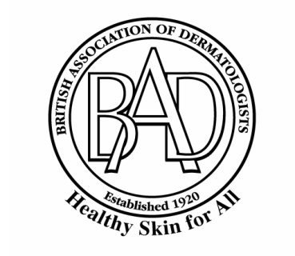
MEDIA GUIDELINES
102nd Annual Meeting of the British Association of Dermatologists
Virtual Meeting: Launching 5th July 2022
Building on its reputation as a high quality internationally renowned event, the British Association of Dermatologists (BAD) is delighted to announce the Annual Meeting for 2022, providing a blend of new scientific presentations with updates from experts in various fields.
We warmly welcome medical and scientific reporters to what promises to be an informative and vibrant meeting. The following information seeks to assist you with your application for a media pass.
The hashtag for this year’s annual meeting will be #BAD2021, to reflect the centenary year of the BAD.
IMPORTANT NOTE: All media must register in advance of the conference. To register, please email comms@bad.org.uk to request an application form.
- Media passes are only available to working journalists, for whom meeting registration fees are waived. Applicants will be required to provide evidence that their attendance results in media coverage of the conference. The following are NOT eligible to apply for a press pass:
- any publication or media outlet’s advertising, marketing, public relations or sales representatives;
- publishers, editors, or reporters from manufacturers’ house organs or promotional publications;
- public relations staff of exhibitors or educational institutions;
- writers creating analyses or reports sold as a commodity to customers;
- other individuals who are not actually reporting on the meeting.

The BAD requests that media do not take screenshots or record any presentations or posters.

The BAD requests that media not pose questions to presenters during the sessions. Members of the media are observers of and not participants in all educational sessions.

- With your application form, please email at least two samples of coverage of any scientific or medical conferences that you have attended. If you have not attended such meetings previously, please provide by-lined samples of your coverage of the specialty of dermatology or samples of other medical, scientific or healthcare coverage. In addition to the above, if you are a freelance applicant, please submit a letter of assignment on letterhead from the publication you are contracted with for this meeting.

- Please note that the BAD Conference has historically been a closed conference for attendance by Members only. Therefore some sessions / posters may include research that is due for publication in a scientific journal and is therefore under publication embargo. It is the obligation of the attending reporter to obtain consent from the relevant speaker / researcher / author to publish details of any materials being presented (by poster, orally or otherwise) at the conference.

- All exhibitor media releases, and media alerts relating to research or launches etc, presented at BAD 2021 must be embargoed to the start of the meeting, July 5th 2022. Please respect the embargo.

- A list of attending media may be available on request from the Press Office. Please let us know if you would prefer not to be included on this list.

- Registered press are prohibited from filming or photographing in all scientific sessions.

If you have any queries, please contact the Media Team, who will be happy to help: comms@bad.org.uk

